Keegan Moynahan *** Worked on with Steph ***

Lab 6



rm(list = ls())

require(palmerpenguins)

sse_mean <- function(x){

values <- !is.na(x)

y <- x[values]

sd(y)/sqrt(length(y))

}

sse_mean(penguins$bill_depth_mm)

sse_mean(mtcars$mpg)



two_group_resample_diff = function(x, n_1, n_2)

{

values <- !is.na(x)

y <- x[values]

z <-sample(y, n_1, replace = TRUE)

v <- sample(y, n_1, replace = TRUE)

diff_in_means =

mean(z) - mean(v)

return(diff_in_means)

}

two_group_resample_diff(penguins$bill_depth_mm, 100, 300)

1. This function performs Monte Carlo resampling, and it stimulates a NULL hypothesis.
2. Chart, histogram

   Description automatically generated
3. 0 mean differences had a magnitude of 5.8 of greater.

flipleng_mean<-sum(abs(mean_differences)>=5.8)

1. I would expect to observe a difference in mean flipper length of 5.8mm or greater in 1 of 10 million experiments

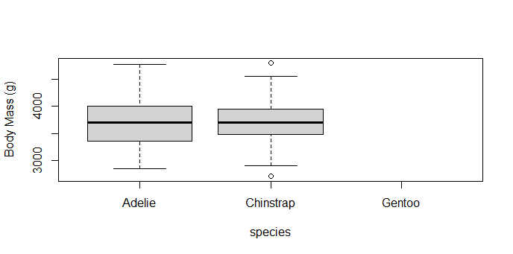

1. 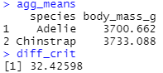
2. The p-value of 0.5879 or 58.7% is saying that 58.7% of the differences in means will be greater or equal to the mean. 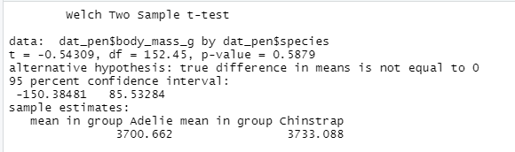
3. 663 or 66.3% of differences were greater than “diff_crit”
4. Chart, histogram

   Description automatically generated